Oliver Collins-Cope

2102775@rutc.ac.uk

Learning Aim A

Investigate the principles and methodologies of IT project management as used in the industry.

unit 09 it project management

Assignment 1

Contents

# Introduction

IT project management is involved in almost every part of IT, as when working through different projects, whether it be developing software, making a game, or even producing an operating system, it is crucial to plan and manage the project constantly in order to ensure constant communication between departments, with everyone knowing what they have to specifically work on. Furthermore, IT project management ensures that the processes of the project are efficient and effective.

# What is a project?

A project can be defined as a sequence of tasks that have to be completed to finish a larger task, usually within a define beginning and end period (deadline). Projects often include a budget to meet these goals and are undertaken by individuals or groups with the tasks broken down to complete sequentially in order to achieve the next goal.

Within projects it is crucial to break down the goal into manageable and doable tasks which can be completed by the members, otherwise the chances of becoming overwhelmed with the work and designing and developing in the incorrect order, which can cause catastrophic consequences later down the line due to your code and design being dependent on each other.

A project can also be displayed through three primary points of focus:

* Time
* Budget
* Scope

Time refers to the time spent on the project, including beginning dates and deadlines to be completed by.  
Budget refers to how many resources have been allocated to the project, whether it be manpower or funding.  
Scope of the project refers to documenting the project boundaries and what the main objectives are.

This diagram can help to understand the relationship between the points of focus.

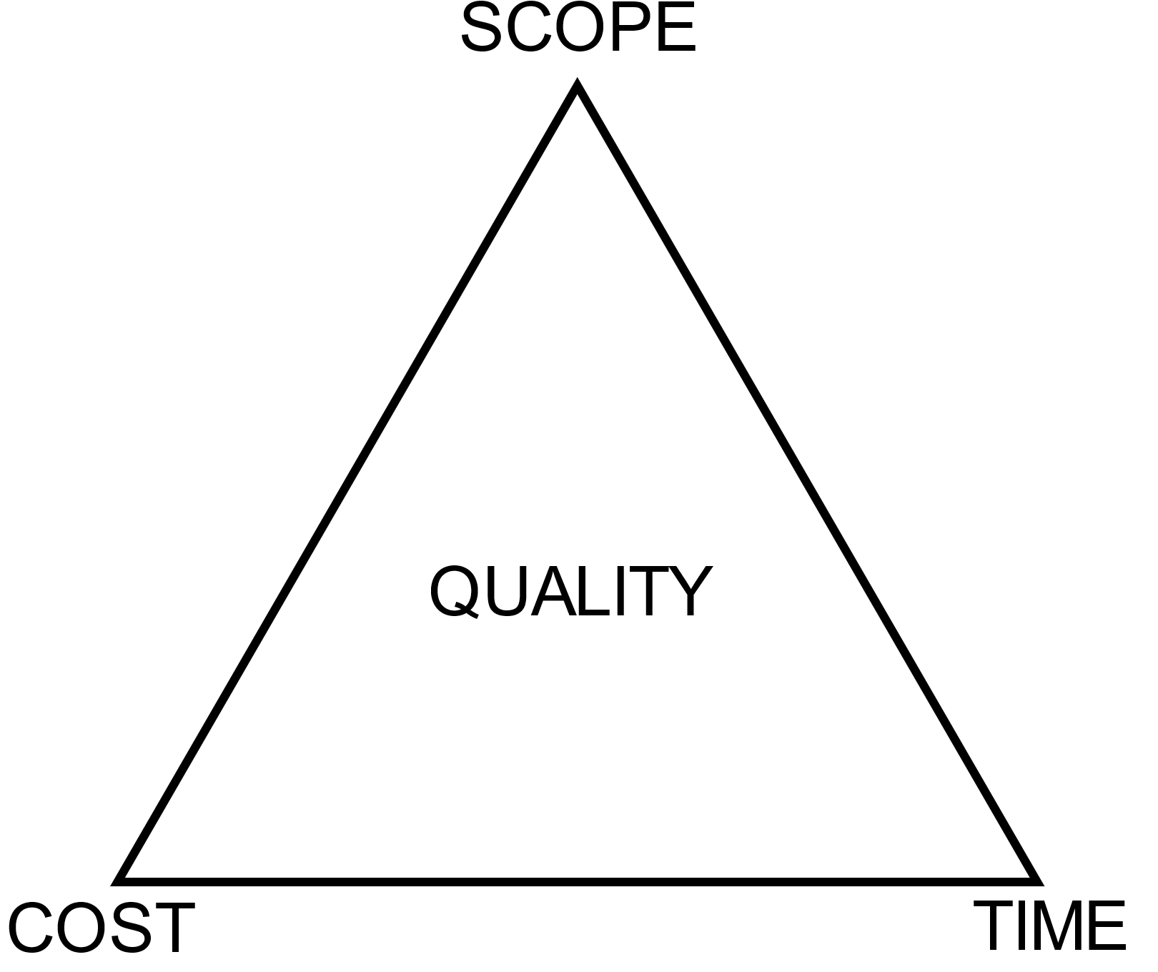

## Difference between a project and a process

It can often be confusing to understand the difference between projects and processes and their relationship with each other, including how they communicate, so it is important to clarify how these vary and what the key differences are.

While a project is usually long term, including a start and end date, processes are established procedures that help with ongoing work. These can be changed constantly and are not strict in what they contain. To help further understand the difference between a project and processes it can be helpful to view them through their relationship.

C:\Users\2102775\Downloads\pjct x prcss.drawio.png

Through this we can understand that a project has many processes, however a process belongs to the instance of that project. This means that a project is a parent process (usually) and the process is born out of the project. While there are some scenarios where a project can also be a process or be born out of a project (making it a process), this is rare and only seen in much larger scale projects made up of multiple smaller ones.

## What do IT projects include?

IT projects in particular include more specific definitions for what is typically involved in the overall project. In no particular order, this commonly includes:

* Software application development
* Installation of IT systems and networks
* Information collection
* Analysis
* Maintenance

#### Software application development

Software application development consists of physically making the software that the company or individual has been contracted to make (in the example of business). This can also be extended to include processes like design, testing, and refinement. Generally, software application development will happen once the requirements and design of the application has been reviewed and approved by the client and project manager, ensuring that everyone is happy with how the software will be developed.

#### Installation of IT systems and networks

Installation of IT systems and networks can refer to both physically and digitally installing IT systems for a company or individual.

Physically installing IT systems and networks is comprised of being on site in the location and manually installing the IT system, whether it be a desktop computer or a server rack for the company, both vital components for businesses to function. This can also include mundane jobs like establishing cable links between the servers and desktops so they are able to access each other.

Digitally installing IT systems consists of installing software for the users to use so they are able work with the required applications for their business or company projects.

#### Information collection

Information collection within IT projects refers to activities where members of the project are able to share data with each other to help advance the project.

An example of a common information collection activity would a meeting, where people establish what they are doing and what support or blockers might be affecting them in their work. Furthermore, meetings will also happen between the client and company in order to remain updated about their project and allow for new input from the client incase situations arise.

#### Analysis

Analysis within an IT project refers to analysing the requirements of the job and what will need to be accomplished in order to achieve success. This can vary from analysing what the program that will be developed is supposed to do and seeing what steps have to be taken to achieve this goal.

#### Maintenance

Maintenance in an IT project means to ensure that the delivered program will continue to function smoothly, providing software updates to the technology and fixing any bugs that occur to destabilise the program.

## What is project management?

### Planning

### Organisation

### Controlling

## Project life cycle

# Different project management methodologies

## Projects IN Controlled Environments (PRINCE2)

## RAD

## Waterfall

## Agile

# Project Management structures

## User requirements

## Protect job roles and responsibilities

## Quality Assurance

## Operational test environment

## Live deployment

# Comparison of different methodologies and structures

# Evaluation of different methodologies and structures